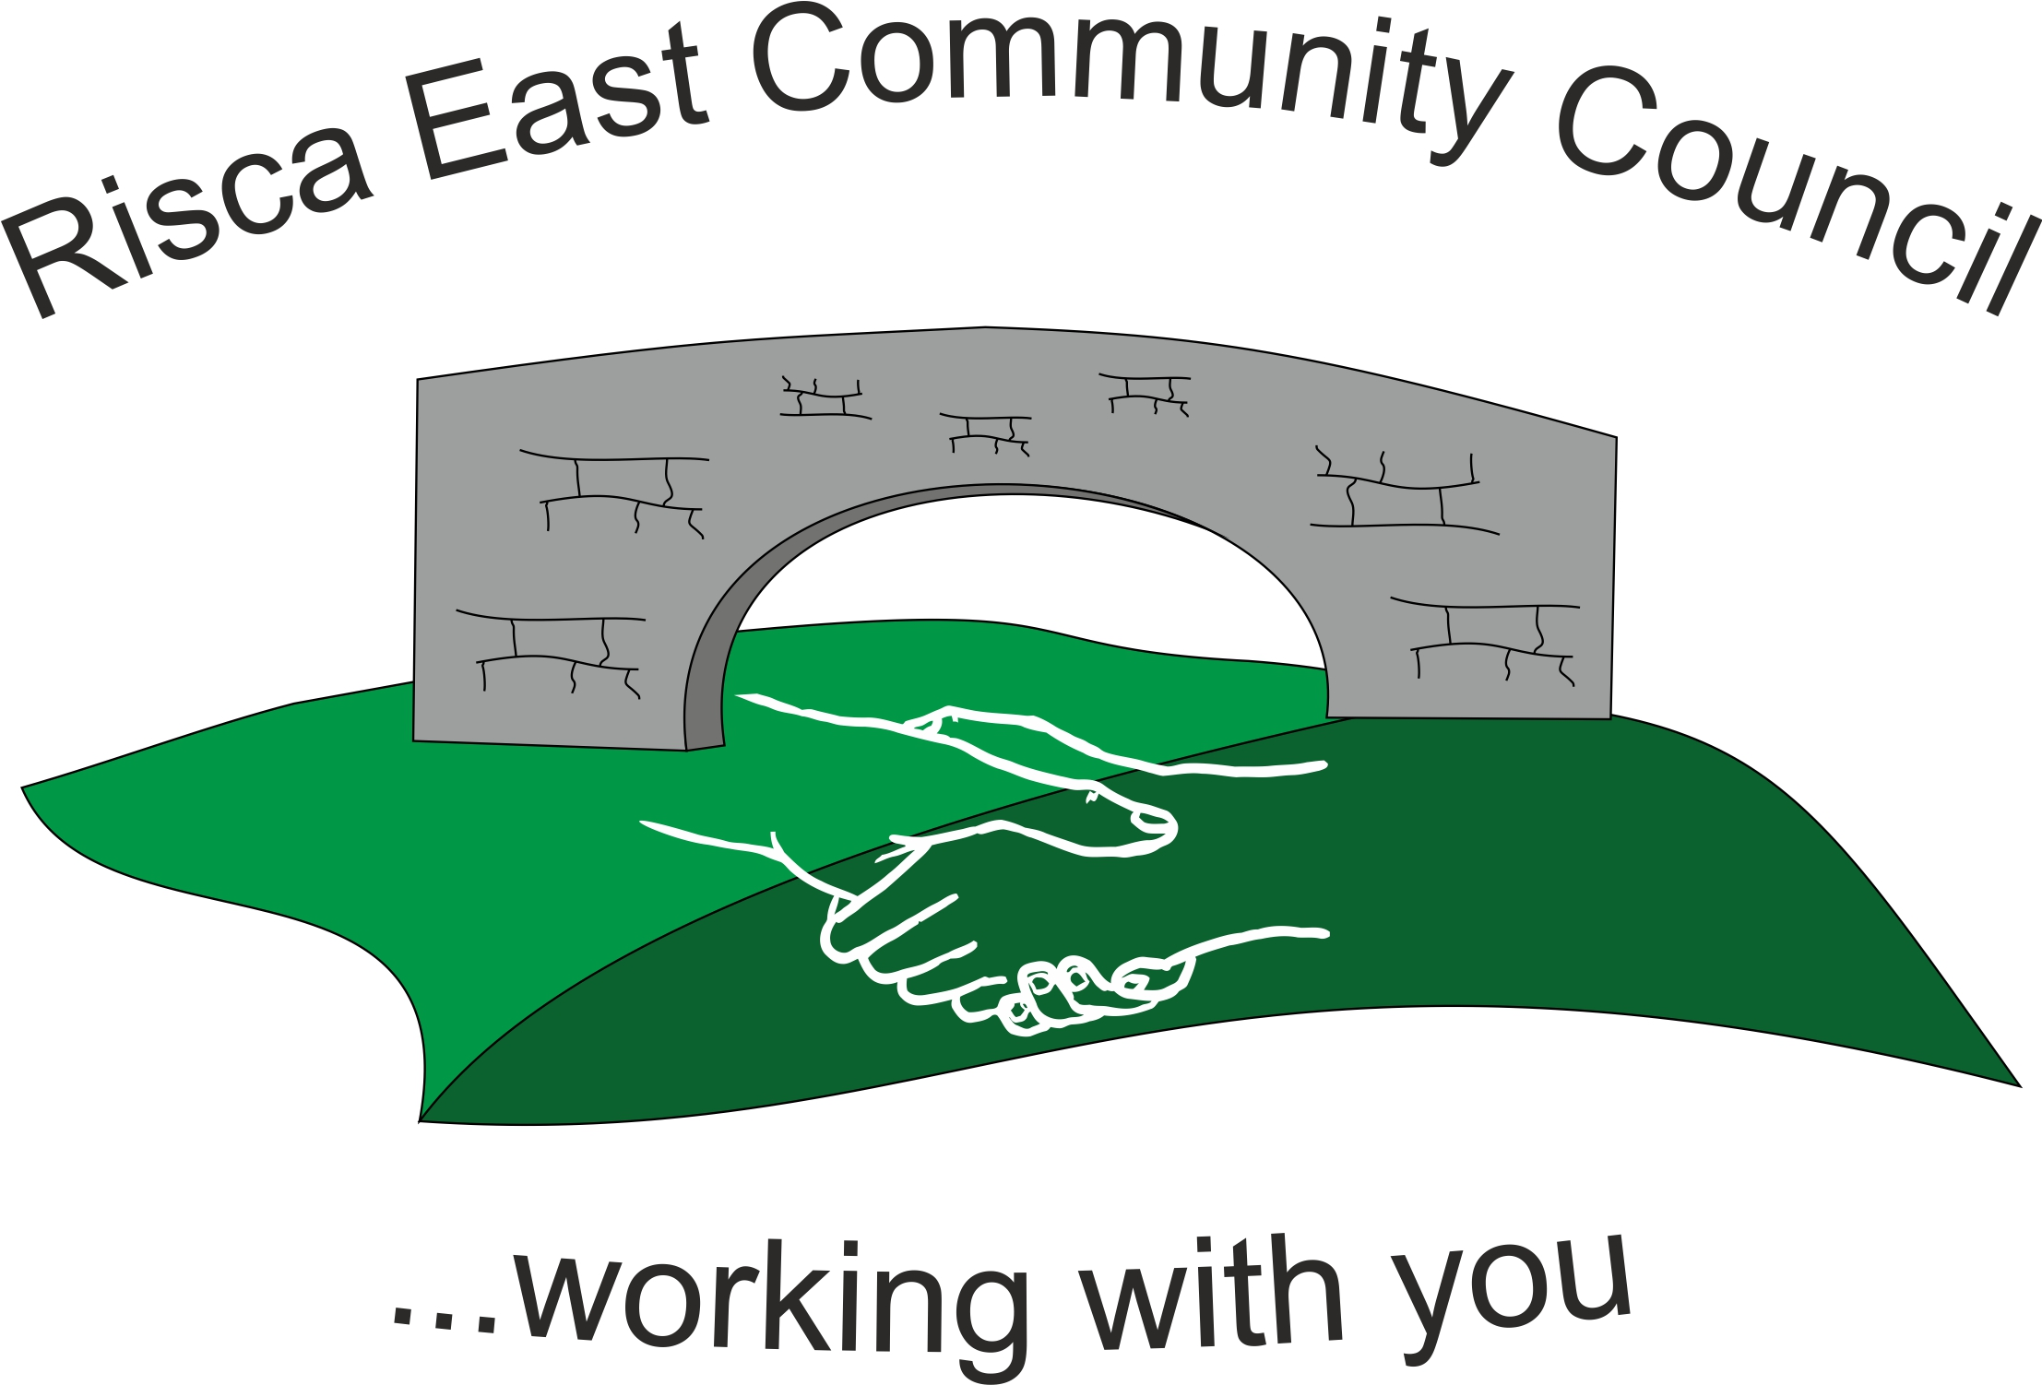 | Clerk/RFO Nicola Roberts  Village Farm  Manmoel  Blackwood  NP12 0RW  Tel. 07904 061754  www.riscaeastcc.org.uk  e-mail riscaeastcommunitycouncil@outlook.com
12-6-24 Meeting started 5:50 pm

7/24/1 Attendance and Apologies
To record attendance and receive apologies.
6/24/1.1 Community Councilors present – Councilors , Bernadette Martin, Zoe Davies, Brandon Ham, Nigel George, Philippa and Arianna Leonard, Roger Smith and Cllr Chris Thomas and Cllr Vim Goryiana. Chair was Cllr Nigel George..

7/24/2 Minutes of the previous meeting
These were received as a true record Cllr Arianna Leonard proposed and Cllr Bernadette Martin seconded that the minutes were correct.

7/24/3 Matters arising
(a)Xmas lights –The Clerk shared an email reply from Elsbury stating that the lights would be behind a large delivery of pallets and they would need to confirm when it would be suitable to collect the lights. To be chased up next week.
(b) Xmas party – The committee doubled checked that the venue was booked for the Christmas Party.

7/24/4 To receive the financial report from the Clerk
7/24/4.1 The clerk ran through the report and the proposed expenditure was agreed. Approval was given for the cheques itemised, the bank balance was £31,247.79.

- Financial report was accepted
- Committed spend –nothing further to be added at this time.

7/24/5 Correspondence

An email was received from Elsbury – point discussed under matters arising above.
Choir Tshirts – an email was received but no funding application was received. Clerk to send a funding application.
Letter received from a company chasing payment – after discussion it was thought that this could be an outsourced hosting company for the website. Further investigation needed before invoice is paid.
Email was received off the Borough Council asking for contribution to events in the Risca Town. Clerk was asked to let them know that we are not part of the town and no events were held in Risca East.

.

7/2/6 – Events –

7/24/6.1. An event meeting was to be arranged for August as the last one had to be cancelled. The meeting is to be held in the Darren on 8/8/24

7/24/7 – To receive the report from Community Councillors
7/24/7.1 Signs on the subway announcing that it would be closed for 12 weeks.

7/24/7.2 The subject of double yellow lines has been raised by some in the community. These were to commence in more of the problem areas.

7/24/7.3 The fencing for the TySign park is to be funded out of the Community Empowerment Fund. Some design alternations had to be made to comply with Housing stipulations.

7/24/7.4 St David’s is now on the open market to be sold. This could present some problems with the Deliberator. The clerk is to make enquiries to ensure we are aware of what needs to be followed if it needs to be moved.

7/24/7.5 Footpath by the Cadets hut is unsafe and the County Councillors to take this further.

7/24/8 To discuss local issues raised by Councilors

There was graffiti over the park bench – there were special wipes in the TLC that would remove this.

7/24/9 Planning Notifications
None noted.

7/24/10 Any other business –

Newsletter – a few note were handed in and those still outstanding were promised by the end of the following week.

The remembrance service was discussed – it was noted that Cllr Chris Thomas was to read at the service and serve on the joint committee.

Date of next meeting 13th September 2024 at 5.30 pm.

Meeting closed 18:55 pm

Signed……………………………………………………….Chairman 13th September 2024

