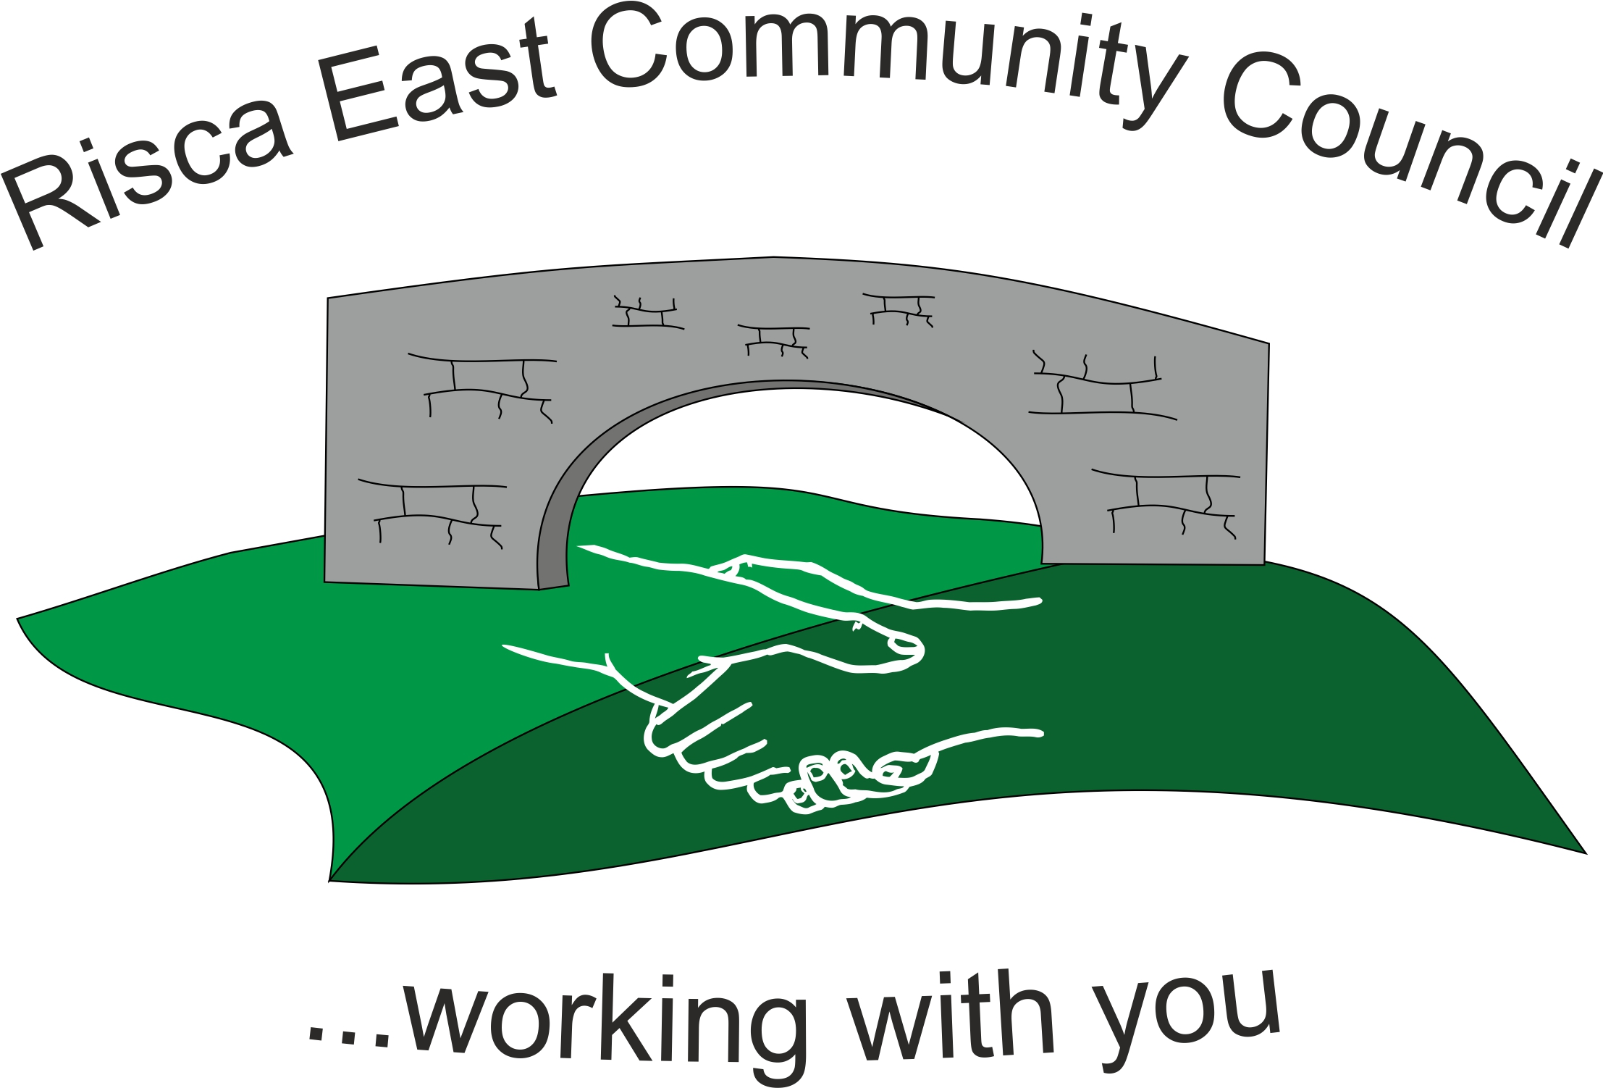 | Clerk/RFO Nicola Roberts  Village Farm  Manmoel  Blackwood  Caerphilly  NP12 0RW  Tel. 07904 061754  www.riscaeastcc.org.uk  e-mail riscaeastcommunitycouncil@outlook.com
5th May 2022
Dear Councillor,
The Annual General Meeting of Risca East Community Council will take place on Thursday 26th May at 6 p.m. in the TLC TySign.
Agenda.
1050 To sign the register and to receive apologies.
1051 To elect a Chairman for year 2022/23.
1052 To elect a Vice-Chairman for year 2022/23.
1053 To sign a declaration of acceptance of office by the newly elected Chairman.
1054 To approve the minutes of the Annual General Meeting held on 20th May 2021
1054.1 Matters arising
1055 To elect representatives to serve on the following committees.
1055.1 Caerphilly County Borough Council Town and Community Councils Joint Liaison Committee. (One representative, Clerk ex officio).
1055.2 Ty Sign Primary School Governing Body. (One representative).
1055.3 Risca Town Centre Management Committee, (Two representatives).
1055.4 One Voice Wales
1055.5 Any other committees nominated and agreed at the AGM.
1056 To decide upon the amount of Chairman’s Allowance for 2021/22 in pursuance of the Local Government Act 1972.

